*Train Simulation*

Use Case Specification Document

**Case Id 8**

**Recommended Changes**

Version No. 1.0Project Document Revision History

|  |  |  |  |
| --- | --- | --- | --- |
| **Version Number** | **Date** | **Revision Author** | **Description of Revision** |
| 1.0 | 3/14/19 | Alex Navarre | Initial Version |
| 2.0.0 | 4/17/19 | Zaid Alsafi | Removing assumptions and things that we might not be able to do. |

Table of Contents

**1. Introduction** **3**

**2. Use Case Information** **4**

2.1 Actors 4

2.2 Use Case Interaction 4

**3. Trigger** **5**

**4. Pre-condition(s)** **5**

**5. Post-Condition(s)** **5**

**6. Use Case Swimlane Diagram** **6**

**7. Main/Basic Flow(s) of Events** **6**

**8. Alternative/Exception Flow of Events** **7**

**9. Assumptions/Business Rules including Non-Functional Requirements** **7**

# 1. Introduction

After the user runs the simulation, the program will generate a file that will give the user potential changes that can be made to improve the efficiency of the railway. The system will analyze the data from each simulation run and suggest changes that can be made using the UI, such as:

1. Adding new tracks when high edge traffic is found
2. Adding new trains when there is a high arrival/departure delay time
3. Adding stations if new routes may be required
4. Adding hubs if space is needed for new trains, or for easier fueling
5. Choosing secondary route if the current route encounters issues

# 2. Use Case Information

## 2.1 Actors

|  |  |  |
| --- | --- | --- |
| **Actor Name** | **Role** | **Description** |
| Suggestion System | Main Actor | This is a system within the program that will search for problem areas after a simulation runs and give suggested changes to the user. These changes will be chosen from a pre-determined set of responses that could help improve railway efficiency. |
| User | Secondary Actor | This is human actor that will directly influence and access the external file that is generated by the suggestion system. Changes made by the user to the simulation will affect the outputs from the suggestion system. |

## 2.2 Use Case Interaction

A list of predecessors use cases are as follows:

Use Case 1 – Setup Initial State: In order to receive feedback on a simulation run, the user must setup their initial system.

Use Case 2 – Add/Remove Trains: Addition or removal of trains will directly affect the suggestion results given by the system.

Use Case 3 – Edit Railway: Addition or removal of stations, hubs, and individual edges will directly affect the suggestion results given by the system.

Use Case 4 – Adjust Weather: Addition, removal, or severity change of the weather will affect the possible suggestions given by the system.

Use Case 5 – Update Graph: Application of user changes between simulation runs will create a new simulation graph. The new graph will require a new suggestion file to be generated.

Use Case 6 – Run Simulation: Running a particular simulation will generate the data used to provide the user with automated feedback from the suggestion system.

Use Case 7 – Track Statistics: This is the act of collecting and recording important information that can be used for the suggestion system to make decisions.

A list of successors use cases are as follows:

Use Case 9 – View Statistics: Viewing of the suggested changes file will be a part of viewing the overall statistics

Use case 10 – Rollback Simulation History: This is the final step in the program, it logically comes after all other use cases.

# 3. Trigger

The use case is triggered when the user finishes a simulation run. After each simulation run, the program will generate a suggested changes file for the user that can be applied to the following simulation runs.

# 4. Pre-condition(s)

4.1 To create a suggested changes file, the user must create and run a simulation

# 5. Post-Condition(s)

5.1 After the suggested changes file is created, the user must choose to view it using the UI

# 6. Use Case Swimlane Diagram

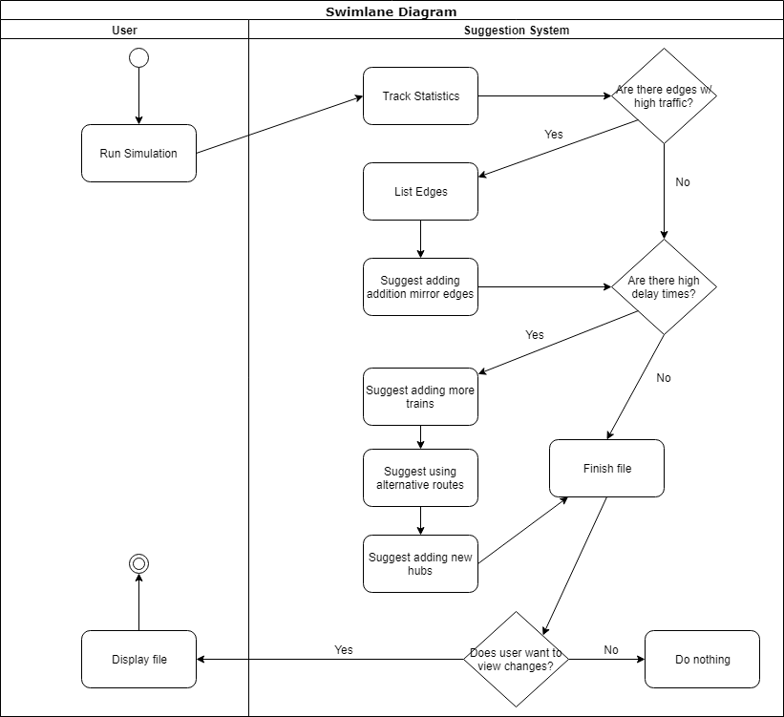

# 

# 7. Main/Basic Flow(s) of Events

7.1 User creates and runs a simulation in order to generate data to be used to create a suggested changes file.

7.2 After file creation, the user will be prompted to view the file.

7.3 Following simulation data will also be saved on the suggested changes file.

# 8. Alternative/Exception Flow of Events

8.1 The file will not be created, and an error message will be displayed if the user has not run at least one simulation.

# 9. Assumptions/Business Rules including Non-Functional Requirements

9.1 The user must run at least one simulation in order to create a suggested changes file.

9.2 The file should contain all sets of suggestions in chronological order.

9.3 The file creation and editing should not slow down the flow of the program a lot